1. I had an old lab of ESXI/vCenter, but the free license is expired now.  
   It could have been good to have the VMs on ESXI since we can automate their creation with ansible, but anyway, I will use VMWare Workstation 15 for local 2 VMs as a preference.
2. Create VM1:
   1. Choose create new:  
      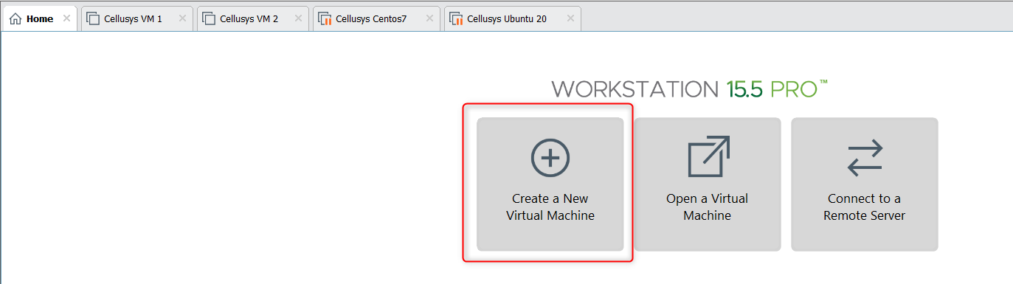
   2. Choose to attach the iso file later:  
      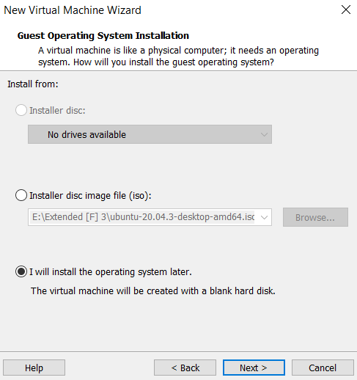
   3. Choose Linux Ubuntu 64-bit:  
      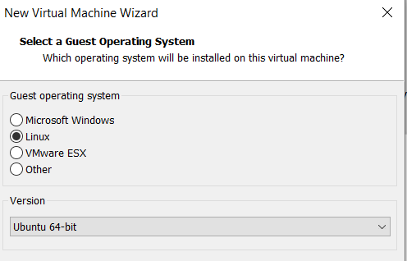
   4. Write a hostname:  
      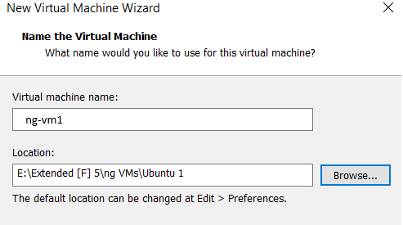
   5. Choose 2 or 4 cores:  
      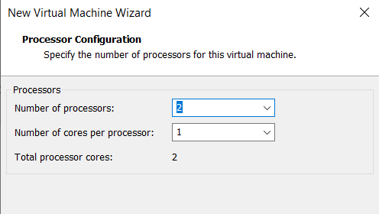
   6. Choose 2GB or 4GM RAM:  
      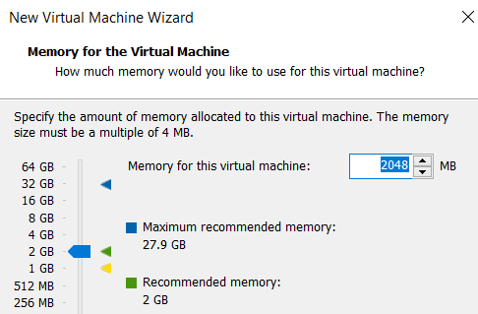
   7. Networking configuration will be modified later, choose anything here:  
      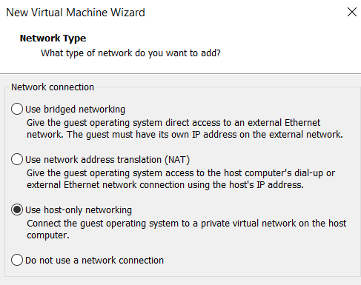
   8. 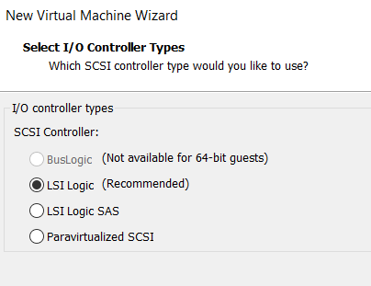
   9. 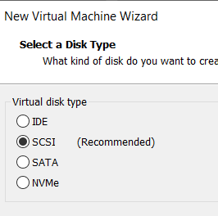
   10. 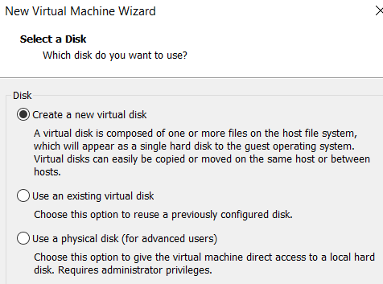
   11. 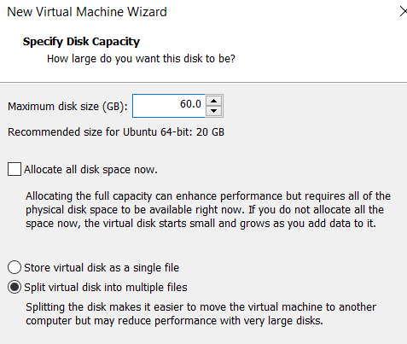
   12. 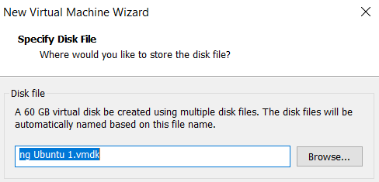
   13. Attach the iso file to the virtual disk driver:  
       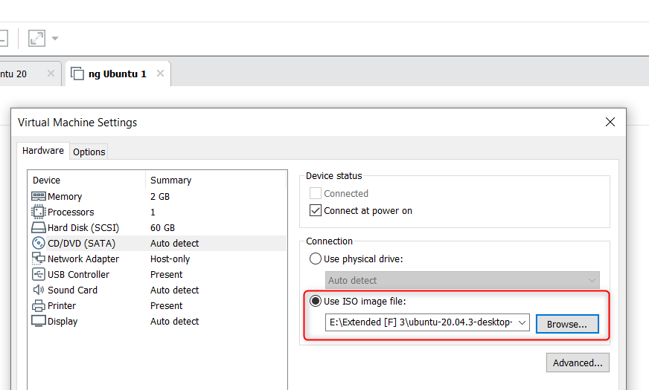
   14. Now run the VM:  
       Installation is GUI based, and easy to be done.  
       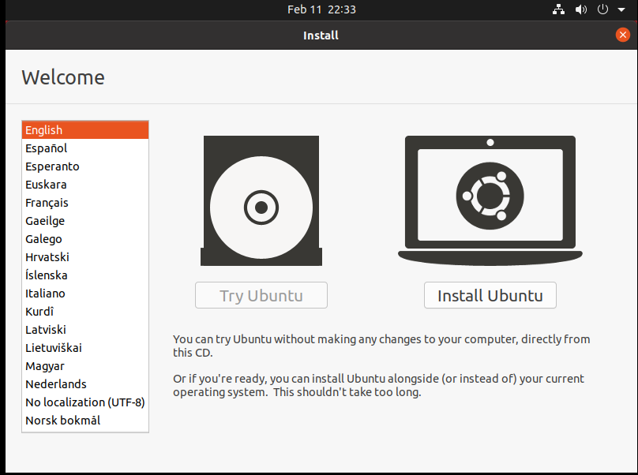
   15. 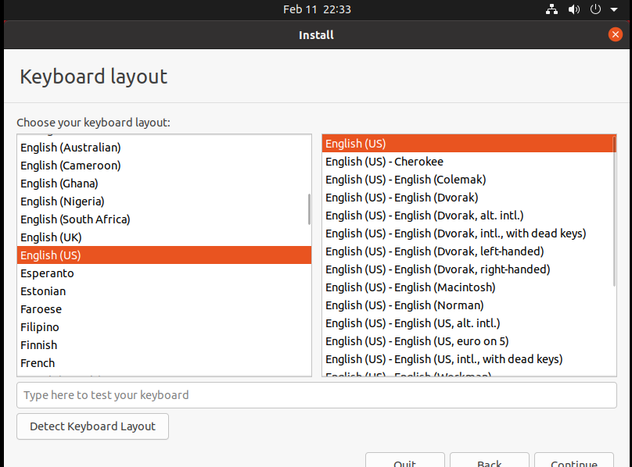
   16. 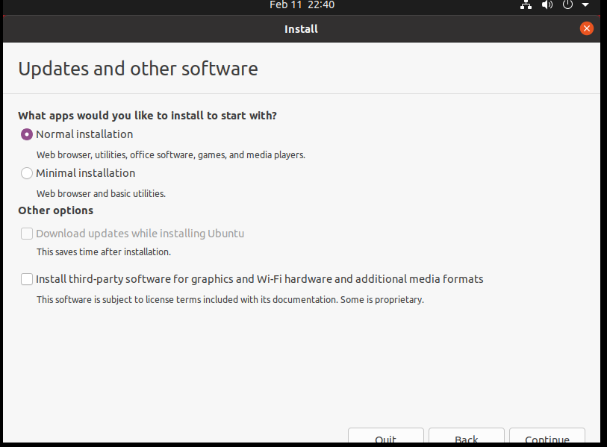
   17. No specific portioning to be used here (just keep everything under / in this example).  
       (we can for example in a production environment create 2 partitions: / and /var, or create partitions following security hardening recommendations).  
       And ext4 format will be used.  
       No LVMs to be used as well.  
       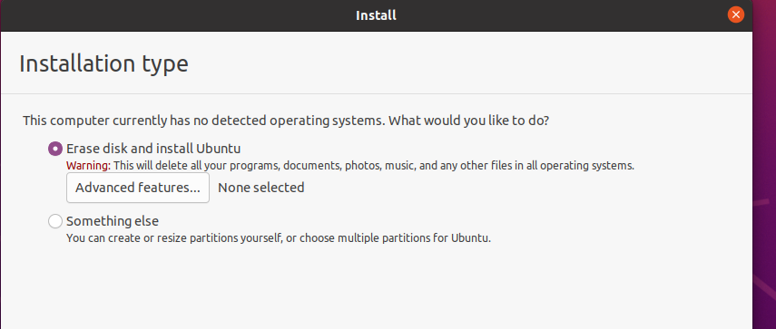  
         
       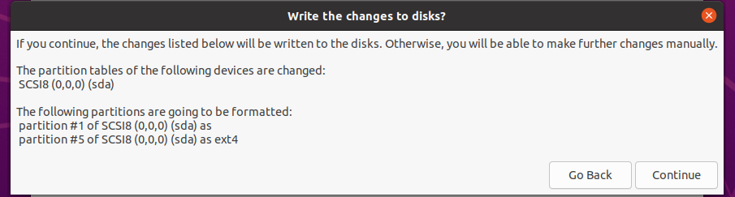  
         
       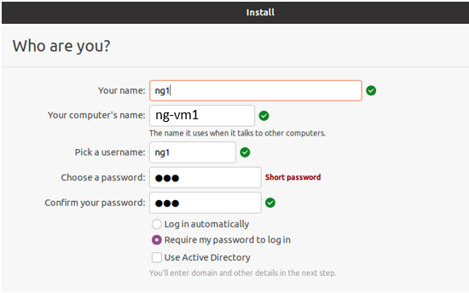
3. Creation and Installation of VM2 is the same.
4. Set up networking:
   1. Add another NIC to each VM from the VM settings:  
      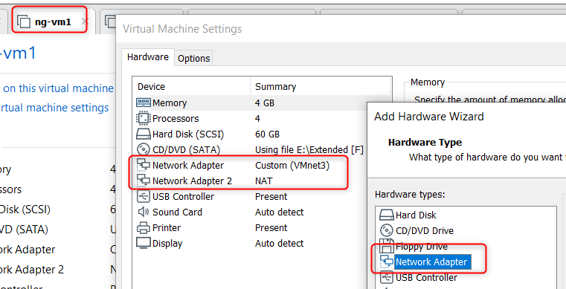
   2. Our lab should look like:  
      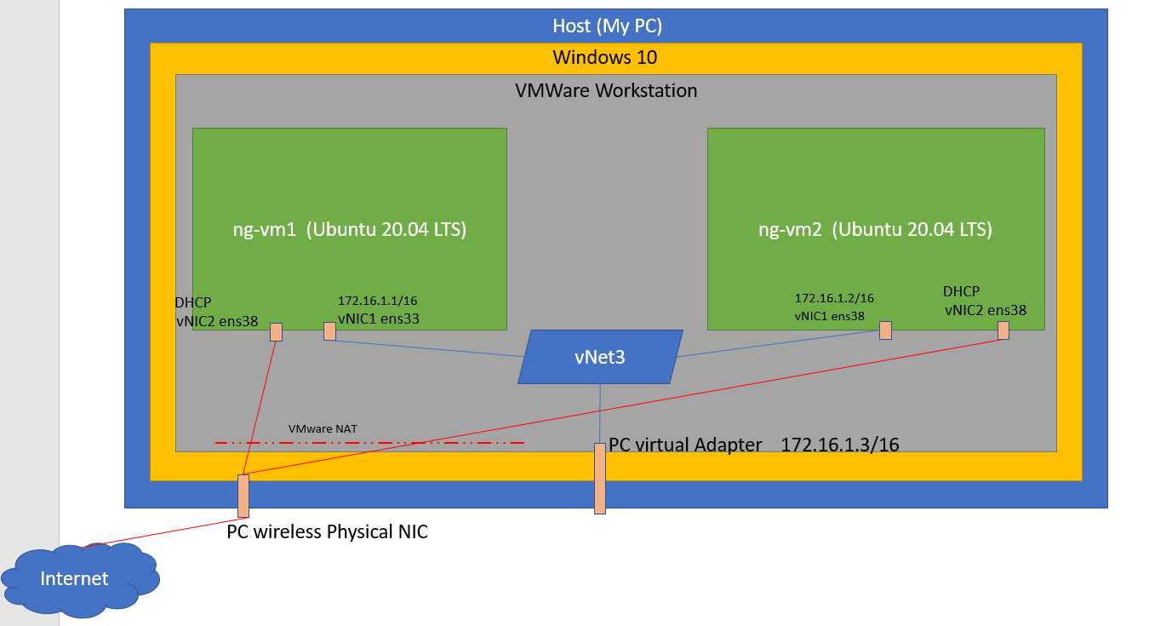
   3. Create the vNet3:  
      From VMware virtual Network Editor, create a virtual switching network:  
      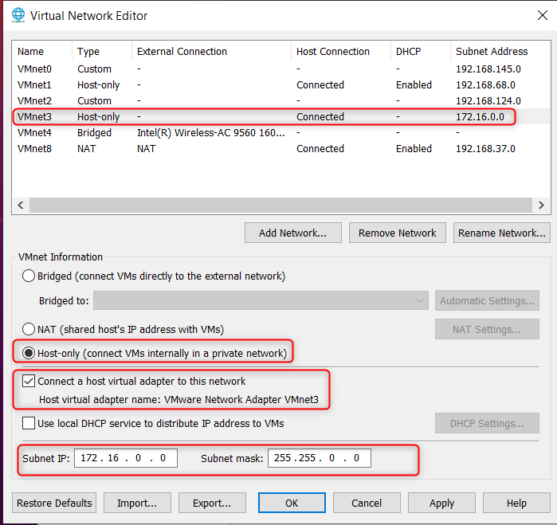
   4. Connect ng-vm1 vNIC1 to vNet3:  
      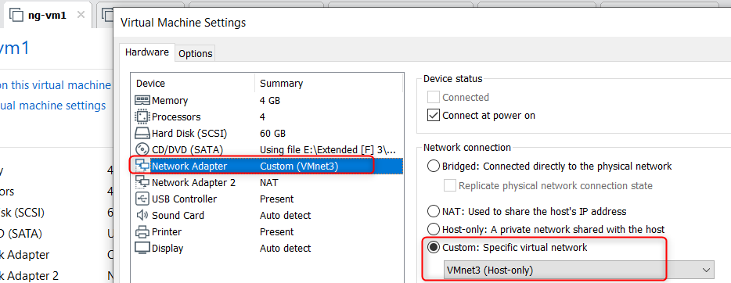
   5. Connect ng-vm2 vNIC1 to vNet3:  
      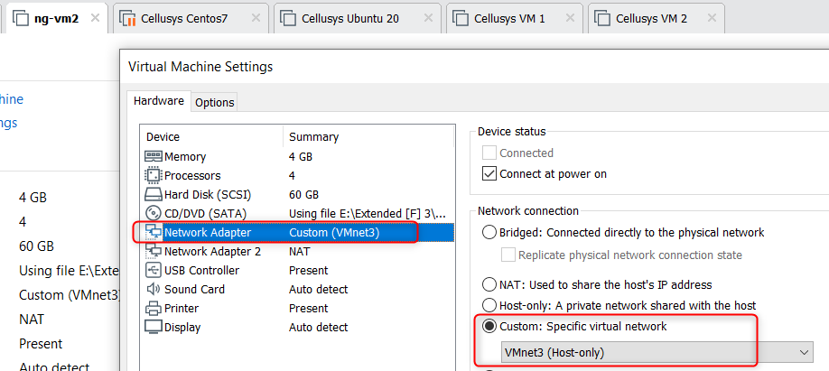
   6. When vNet3 is created, a virtual adapter for the host is created and connected to it,   
      Configure the virtual adapter of my pc (Host) with an IP:  
      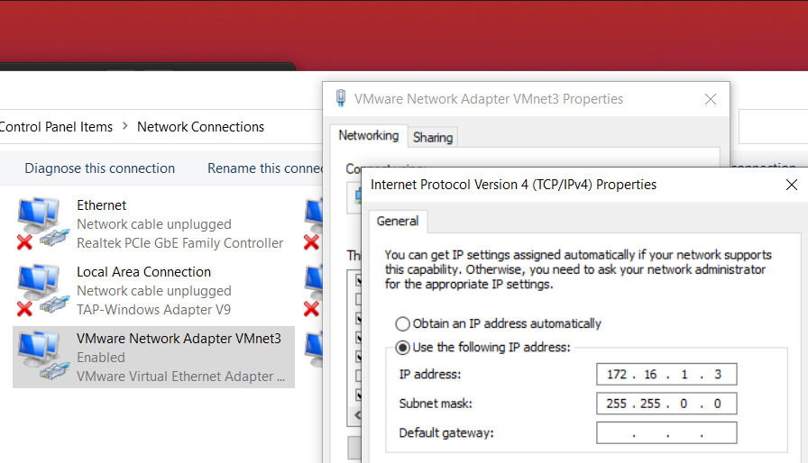
   7. Configure an IP for the ng-vm1 vNIC1:  
      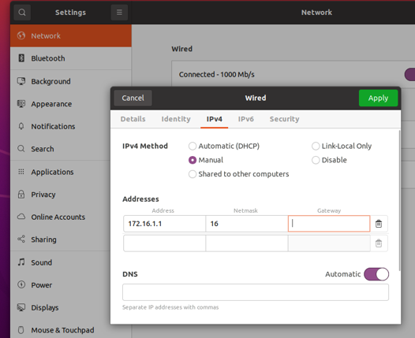
   8. Configure an IP for the ng-vm2 vNIC1:  
      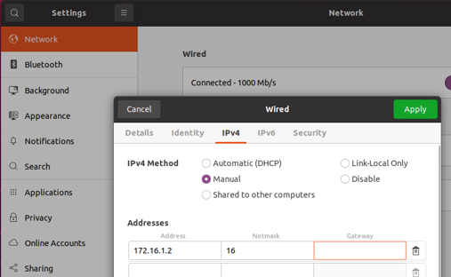
   9. Now connect ng-vm1 and ng-vm2 to VMware NAT network to go to internet through the host physical network card:  
      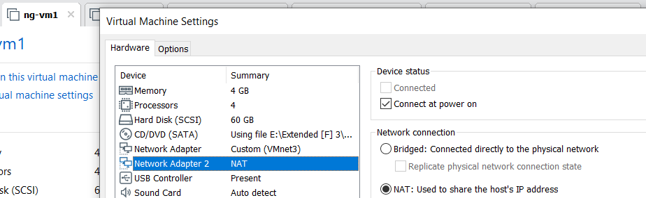  
        
      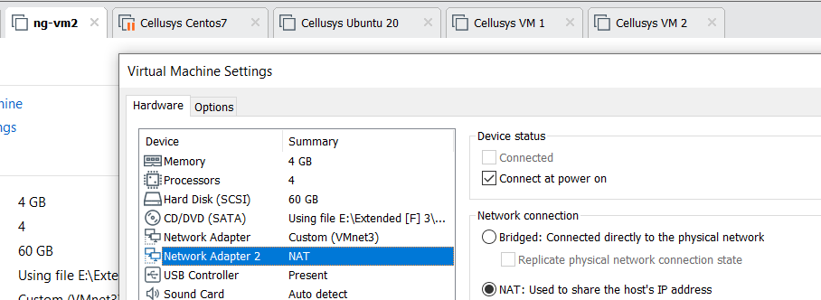  
        
      and from ubuntu interface card settings, configure those with DHCP.